From: https://thegrayzone.com/2021/08/30/afghanistan-beltway-medias-permanent-war-state/
Via: https://consortiumnews.com/2021/09/01/the-beltway-medias-loyalty-to-permanent-war-state/
By: Gareth Porter
Volume & Date: Volume 26, Number 245 –Thursday, September 2, 2021
Consortium News:
AFGHANISTAN, AMERICAN-EMPIRE, ANALYSIS, BIDENADMINISTRATION, COMMENTARY, IRAQ, LEBANON, MEDIA, MIDDLEEAST, MILITARISM, MILITARY, PENTAGON, PROPAGANDA, U.S.
The Beltway Media’s Loyalty to Permanent War State
Biden’s popular and long overdue retreat from Afghanistan exposed big media’s de facto merger with the military, writes Gareth Porter.
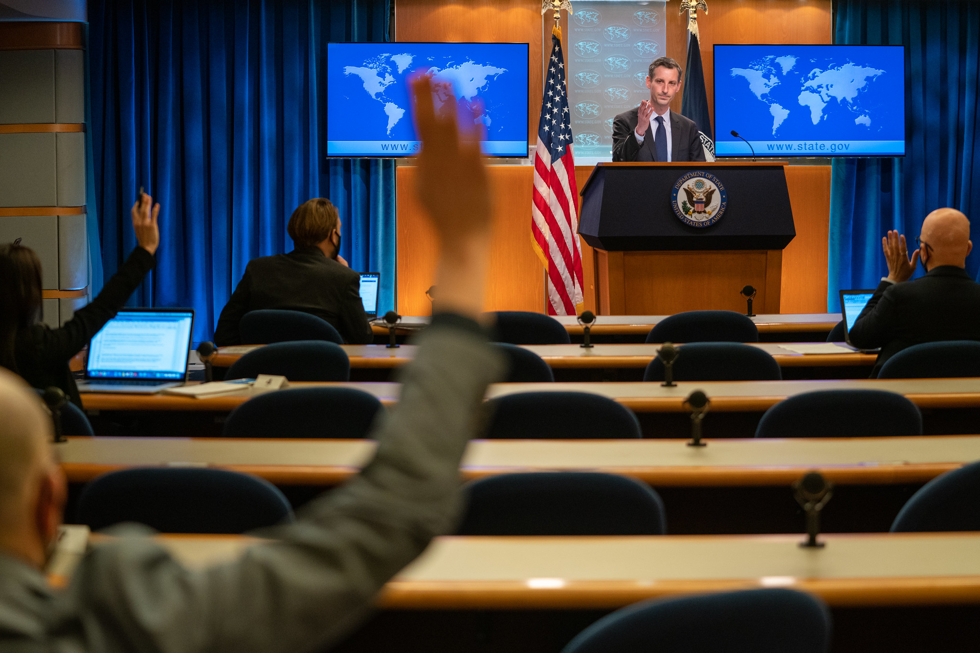
U.S. State Department Spokesperson Ned Price holding press conference in March. (State Department, Ron Przysucha)
In the wake of a remarkably successful Taliban offensive capped by the takeover of Kabul, the responses of corporate media provided what may have been the most dramatic demonstration ever of its fealty to the Pentagon and military leadership. The media did so by mounting a full-throated political attack on President Joe Biden’s final withdrawal from Afghanistan and a defense of the military’s desire for an indefinite presence in the country.
Biden’s failure to establish a plan for evacuating tens of thousands of Afghans seeking to the flee the new Taliban regime made him a soft target for the Beltway media’s furious assault. However, it was Biden’s refusal last spring to keep 4,500 U.S. troops in Afghanistan on an indefinite basis — flouting an aggressive Pentagon lobbying campaign – that initially triggered the rage of the military brass.
The media offensive against Biden’s Afghan withdrawal advanced arguments that the military could not make on its own — at least, not in public. It also provided the military with important cover at the moment when it was at its most vulnerable for its disastrous handling of the entire war.
Among the most disingenuous attempts at salvaging the military’s reputation was a Washington Post article blaming the Afghan catastrophe on an over-emphasis on “democratic values” while ignoring the the tight alliance between the U.S. military and despotic warlords which drove local support for the Taliban.
Playing the Al Qaeda Threat Card
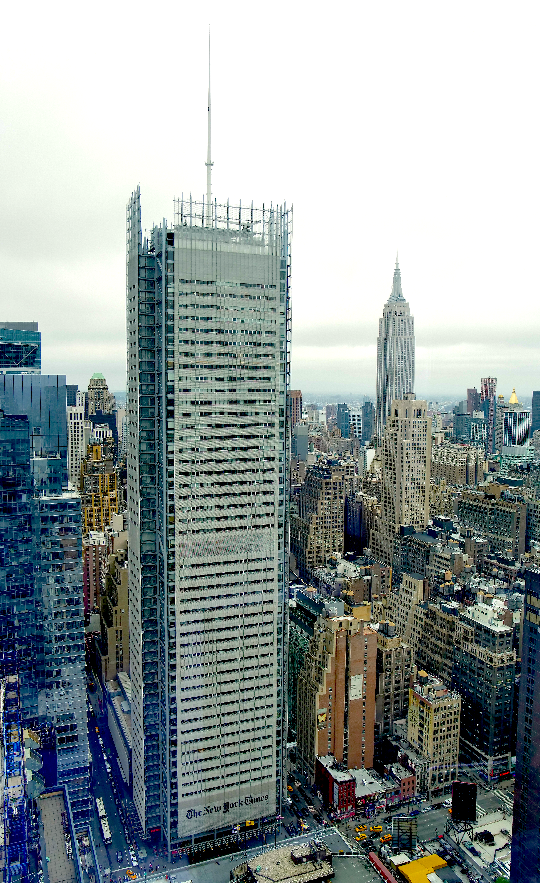
The New York Times building in Manhattan. (Defears, CC BY-SA 4.0, via Wikimedia Commons)
On the eve of the Taliban takeover of Kabul, The New York Times’ David Sanger and Helene Cooper fired the opening salvo of the Beltway media’s assault on Biden’s decision. Sanger and Cooper began by acknowledging that the U.S. military had “overestimated” the results of its intervention for years, and that the failure of the Afghan government to pay soldiers for months had sapped the will to resist the Taliban.
But they then homed in on Biden’s refusal to keep troops in Afghanistan for counter-terrorism purposes. Recalling that Joint Chiefs Chairman Gen. Mark A. Milley had tried in the spring to compel Biden to maintain 3,000 to 4,500 troops in the country, Sanger and Cooper cited “intelligence estimates predicting that in two or three years, Al Qaeda could find a new foothold in Afghanistan.”
That speculation was based on the assumption that the Taliban would allow such a development despite its well-established record of opposing Al Qaeda’s use of its territory to plan terrorism abroad. In fact, the Taliban’s policy went back to before 9/11, when Osama bin Laden formally agreed to honor the Taliban’s restrictions while secretly plotting the 9/11 attacks in Germany rather than in Afghanistan.
In the wake of the U.S. withdrawal, the Taliban has an even stronger motivation to prevent any jihadist organizations from planning international terror attacks from Afghan territory.
To support their broadside against Biden’s withdrawal, the Times’ Sanger and Cooper turned to the retired general with arguably the greatest personal vested interest in an indefinite U.S. military presence in Afghanistan: former U.S. commander in Afghanistan Gen. David Petraeus, who oversaw the war effort from 2010 through 2011 and has since led a group of former commanders and diplomats lobbying for an endless U.S. presence in the country.
Petraeus asserted that Biden failed to “recognize the risk incurred by the swift withdrawal” of intelligence drones and close air support, and thousands of contractors who had kept the Afghan Air Force flying.”
Next, Sanger and Cooper turned to Richard Fontaine, the chief executive of one of the most militaristic think tanks in Washington, the Center for a New American Security (CNAS).
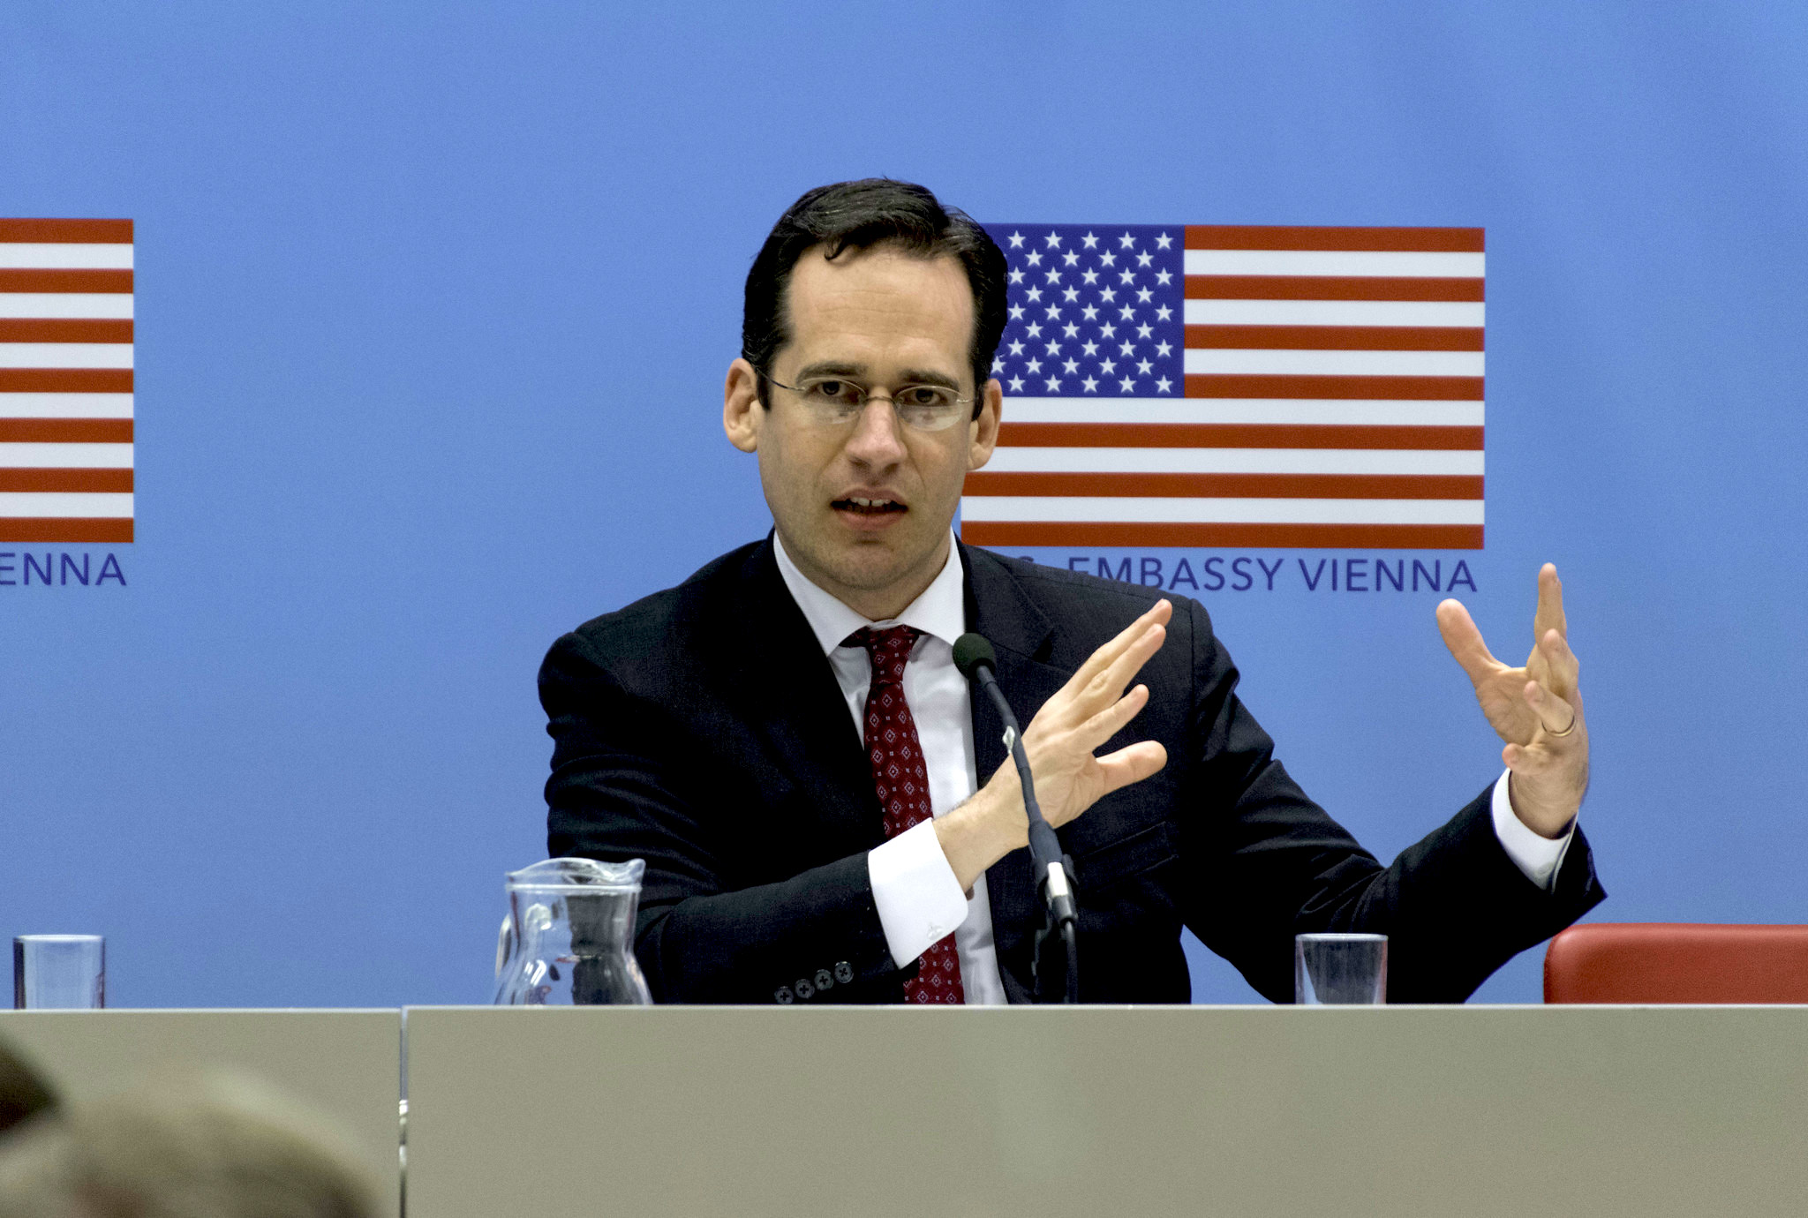
Richard Fontaine in 2019. (U.S. Embassy Vienna)
As The Grayzone has reported, CNAS has reaped millions in funding from the arms industry and U.S. government institutions to advance Pentagon and military thinking inside the Beltway. Among the many Beltway media insiders who enjoy writers-in-residence fellowships at the think tank is The New York Times’ Sanger.
For his part, Fontaine compained[sic] that the Biden administration had failed to continue providing the contractors that the Afghan Air Force depended on to keep its planes in the air. But he failed to acknowledge the obvious point that contractors would be unable to function in Afghanistan without sufficient U.S.-NATO troops to provide military protection on the ground.
On Aug. 16, after the U.S.-backed Afghan government was eliminated, the liberal interventionist magazine, Foreign Policy, chimed in with another attack on Biden featuring interviews with “a dozen people who held posts in Afghanistan.” According to Foreign Policy, current and former diplomats anonymously expressed “deep anger, shock and bitterness about the collapse of the government they spent decades trying to build.” Several currently-serving officials were quoted — again off the record — about their considering resigning in protest, citing an “overwhelming sense of guilt and fear for the lives of former Afghan colleagues and local staff whom the American government left behind.”
That same day, The New Yorker’s Robin Wright expressed similar anguish over the harrowing images of U.S. defeat in Afghanistan. In an article subtitled, “It’s a dishonorable end that weakens U.S. standing in the world, perhaps irrevocably,” she lamented that the United States “is engaged in what historians may some day call a Great Retreat from a ragtag army that has no air power ….”
The U.S. retreat from Afghanistan, Wright asserted, is “part of an unnerving American pattern dating back to the 1970s,” starting with former President Ronald Reagan’s pull-out from Beirut and former President Barack Obama’s withdrawal from Iraq in 2011.
Echoing those insisting on an indefinite U.S. military role in Afghanistan, Wright claimed that because the Taliban had “won a key battle against democracy in Afghanistan,” the country would “again, almost certainly become a haven for like-minded militants, be they members of al Qaeda or others in search of a sponsor.”
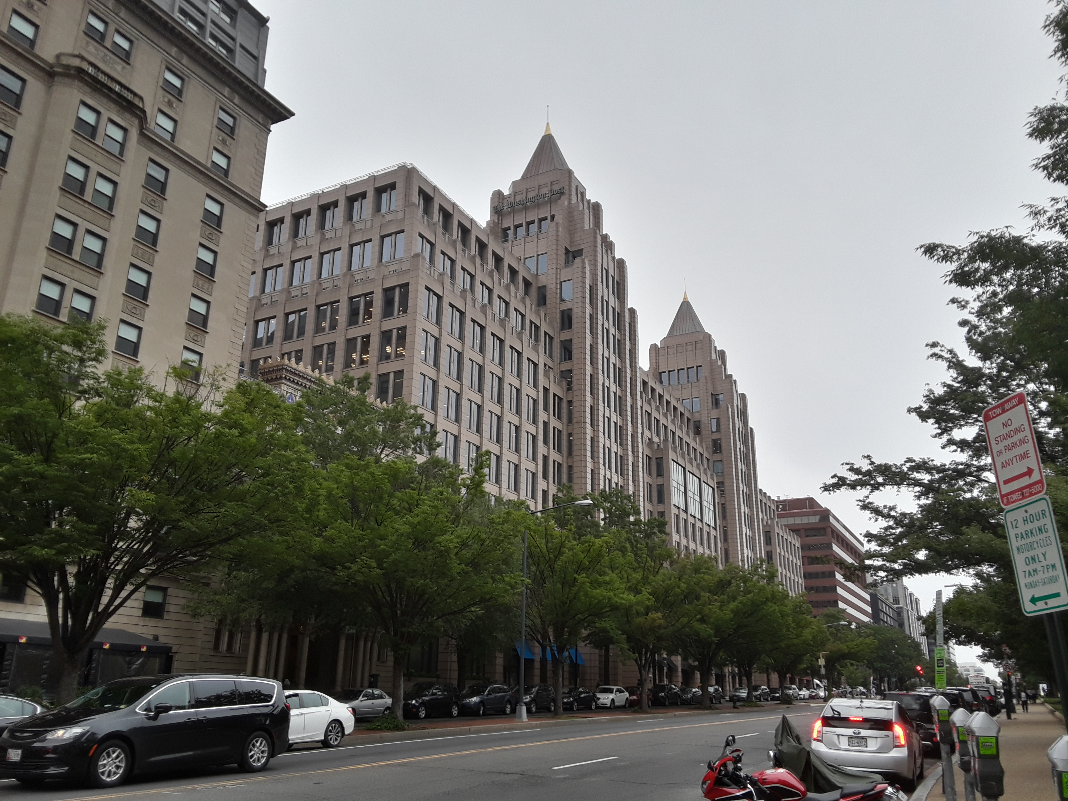
Washington Post’s headquarters in Washington, D.C. (Ser Amantio di Nicolao, CC BY-SA 4.0, via Wikimedia Commons)
Meanwhile, during an Aug. 21 panel on PBS’s Washington Week, Peter Baker of The New York Times, Anne Gearan of The Washington Post and Vivian Salama of The Wall Street Journal formed a one-note chorus blaming Biden’s hasty withdrawal for the crowds of anguished Afghans desperately seeking to escape the Taliban at Kabul’s airport.
The implicit — and clearly fanciful — premise of the discussion was that the United States could have somehow embarked weeks or months earlier on a sweeping program to rescue tens and possibly hundreds of thousands of interpreters and other collaborators with the U.S. military, and that it could all be done cleanly and efficiently, without triggering any panic.
A second theme pressed by The New York Times’ Baker was that Biden had been heedless of the risks of his policy to U.S. national security. Baker said Biden had made up his mind a decade ago that the U.S. must withdraw from Afghanistan and was determined to do it “regardless of what Gen. Milley and others might have warned him about the danger of a collapse.” Baker made the same argument, along with the others embraced by his big media colleagues, in a long-winded Aug. 20 news analysis.
Flournoy Obscures Cause of Military Failure
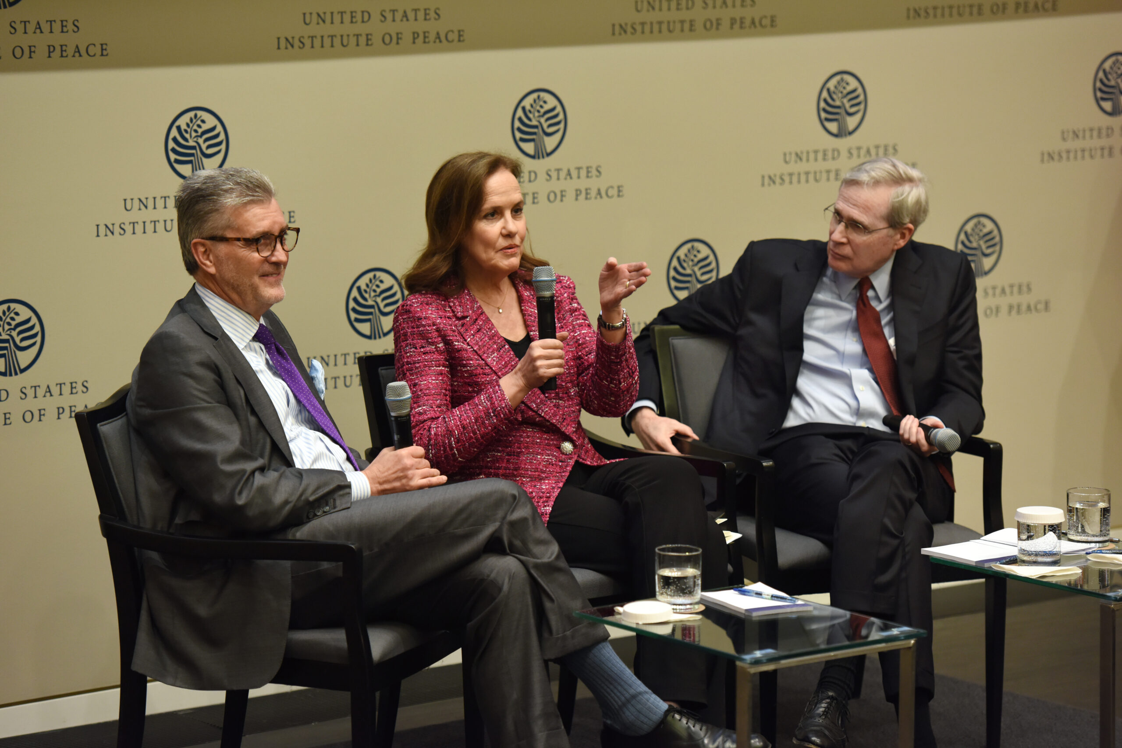
Michele Flournoy in center, with on left, Ambassador Richard Olson, and on right, former National Security Advisor Stephen J. Hadley, February 2020. (U.S. Institute of Peace, CC BY 2.0, Wikimedia Commons)
The Washington Post’s national security reporter, Greg Jaffe, took a different tack from most of his Beltway colleagues in his coverage of the Afghanistan endgame. In an Aug. 14 article, Jaffe implicitly acknowledged the widely-accepted fact that the war had been an abject failure, contradicting claims by military leaders. Unfortunately, the reporter [WaPo / Jaffe] offered space for one particularly credibility-deprived former official that was obviously designed to deaden popular hostility toward those responsible for the fiasco.
Among the most questionable characters to lay into Biden’s withdrawal strategy was Michelle Flournoy, who was expected to be appointed as the next secretary of defense until Biden froze her out because of her role in advocating the failed troop surge in Afghanistan during the Obama administration.
Flournoy had been Obama’s undersecretary of defense and was responsible for supporting the commanders in the field from the Pentagon. Prior to that role, she co-founded CNAS, the arms industry-backed, Democratic Party-affiliated propaganda mill for the Pentagon and military services.
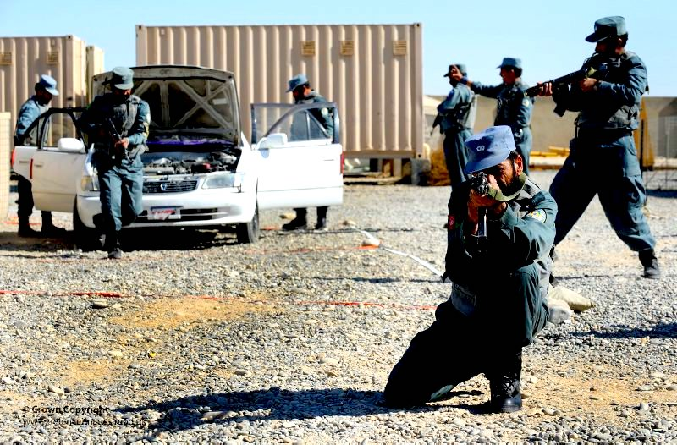
Nov. 13, 2010: Afghan National Police in Helmand Province demonstrate a vehicle search. (DoD, Rupert Frere)
In a revealing interview with the Post’s Jaffe, the former Pentagon official [Flournoy] blamed the failure of the U.S. war in Afghanistan on an excessive commitment to “democratic ideals,” arguing they supposedly blinded the policymakers to the realities on the ground. It all started, she claimed, with “the Afghan constitution that was created in Bonn and … was trying to create a Western democracy.” The policymakers set the bar “on our democratic ideals, not on what was sustainable or workable in an Afghan context,” she added.
But the problem was not an excessive U.S. concern for promoting democracy, but the way that U.S. policy sold out “democratic ideals” to support a group of warlords who represented the essence of anti-democratic despotism.
In explaining the Obama administration’s decision to more than double the totals of U.S. troops, Flournoy claimed that she and other U.S. officials only discovered the festering wound of Afghan corruption when it was too late, fatally dooming the military strategy. “We had made a big bet only to learn that our local partner was rotten,” she insisted.
However, Flournoy deliberately obscured the crucial fact that the U.S. war was based from its very inception on an alliance with a group of corrupt and murderous warlords. The military leadership, as well as the CIA, relied on the warlords because they had militias and were ready to oppose the Taliban. The warlords offered a steady supply of militiamen as police in the provinces and were given well-paid contracts to provide security for the constant flow of convoys to and from U.S. and NATO bases.
But the militia-police maintained their loyalty to their respective warlords, rather than to any civilian government in Kabul, and in return were given a free hand to steal from Afghans, falsely accuse them of crimes, torture them and release them only for a ransom. In many cases, the police extorted money from local families by abducting and raping their wives, daughters and sons — a pattern of abuse documented by Amnesty International as early as 2003.
The Taliban easily ousted the U.S.-supported regime from large parts of Afghanistan’s Helmand province beginning in 2005-06 because of the local population’s hatred of the lawless warlord militias designated by the U.S. military as police. And when U.S. troops re-occupied those districts in 2009, the militias returned to their brutal ways — including abducting and raping pre-teen boys, prompting bitter complaints from the local residents to the U.S. marines and threats to support the Taliban if the U.S. didn’t intervene to stop them. But the U.S. military never moved to disturb its cozy relationship with the warlords.
So Flournoy’s claim that senior military and Pentagon officials were unaware of the corruption of their Afghan allies until after the Obama administration’s massive commitment of troops is simply devoid of credibility. When she and other key policymakers made their “big bet” later in 2009, they were fully aware that the U.S. was backing a group of powerful warlords whose militia-police were committing heinous abuses against the population that forced Afghans to support the Taliban as their only defense.
The patent falsehoods peddled by the Beltway press corps in response to the Biden withdrawal reveals just how tightly they have become linked to the interests of the military and Pentagon. And its flamboyant opposition to a pull-out favored [by] a solid majority of the American public is yet another factor that will accelerate the decline of an already cratering corporate media.
[Author] Gareth Porter is an independent investigative journalist who has covered national security policy since 2005 and was the recipient of Gellhorn Prize for Journalism in 2012. His most recent book is The CIA Insider’s Guide to the Iran Crisis, co-authored with John Kiriakou, just published in February.
This article is from The Grayzone
The views expressed are solely those of the author and may or may not reflect those of Consortium News.

Tags:
Anne Gearan
Center for a New American Security
CIA
David Sanger
Foreign Policy
Gareth Porter
Gen. David Petraeus
Greg Jaffe
Helene Cooper
Mark A. Milley
Michelle Flournoy
Osama bin Laden
Peter Baker
Richard Fontaine
Robin Wright
Taliban
The New York Times
The New Yorker
The Washington Post
Vivian Salama

